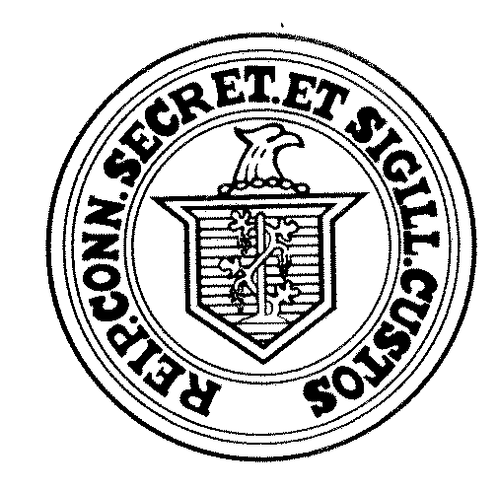
NOTICE OF RECANVASS
November 10, 2022
TO THE TOWN CLERKS OF THE CITIES OF:
SENATE DISTRICT 8 – Avon, Barkhamsted, Canton, Colebrook, Granby, Hartland, Harwinton, New Hartford, Norfolk, Simsbury, Torrington
Re: Automatic Recanvass of Votes Cast at November 8, 2022 Election.
This letter is to notify you that returns on file in the Office of the Secretary of the State indicate that the votes cast for the offices indicated below have resulted in an automatic recanvass:
Senate District 8
Paul Honig 22,821
Lisa Seminara 22,305
Lisa Seminara 641
Total Difference 125
If these totals are in anyway different from those that you have filed or will file with our office, please notify our office immediately as that change may alter the necessity for a recanvass.
Consequently, a recanvass of the votes for all candidates for the above offices are to be made as required by §9-311 of the General Statutes.
Section 9-311 of the General Statutes and our Recanvass Procedure Manual specify in detail the procedure which must be followed. You must immediately impound the voting machines, absentee ballot materials, moderator’s returns and all other notes, worksheets or written materials used in the election to be recanvassed.
The recanvass is to be initiated by you the Town Clerk, promptly notifying the Moderator that it is to be made. (The term “moderator” means, in the case of towns not divided into voting districts, the moderator of the election and in the case of town divided into voting districts, the head moderator of the election.) The Moderator, in turn must immediately summon the recanvass officials by written notice delivered to them personally.
Because the recanvass involves a matter of great public concern, may we urge that upon completion of the recanvass, the Moderator immediately notify our office of the outcome of the recanvass and also amend the head moderator’s return on the election management system (EMS).
As to the time for making the recanvass, may we point out that §§9-311 and 9-2 require that such recanvass must be made on or before Wednesday, November 16, 2022.
If you have any questions in connection with the above, or if we can be of service in anyway, please do not hesitate to call us at 860-509-6100.
Sincerely,
Mark Kohler
Secretary of the State

